BIOLOGY AP, September 2005 Name ____________________________________
Practice QUIZ PERIOD 5 6 7
Ecology

"I understand the Monta Vista Academic Code and will not give or receive any improper aid for this examination. Any violations of this will result in a zero on this exam and an Academic Code Violation in your permanent record." signed ________________________________________

1. As a population biologist you are studying a population of meerkats in the savanna of Africa to see how the recent industrial developments in the area have affected them. On your first trip out, you capture 400 meerkats, tag them, then release them back into the wild. Several weeks later, you return to the same area and capture another 400 meerkats and find that 100 of them have the original tag.
- Based on this information, what is your estimate of the size of the meerkat population? ____________________
- In the following year, you need to calculate the change in this population. You know that in this year, 215 meerkats were born, 87 died, 25 moved into the area, and 9 left the area. Based on the size estimated in (a), what is the new population size? _______________
- The meerkat diet consists of insects such as spiders and crickets. Spiders and crickets feed on grasses. Shade in the trophic level that meerkats fall in on the diagram below.
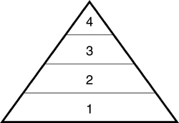
- Individuals in trophic level 2 are known as _________________________________.

- Meerkats typically have 2-4 babies at a time after 11 months of pregnancy. After birth, baby meerkats remain with their mother for several months of nursing. The meerkat is a (choose one): r-strategist k-strategist
- Explain your answer to part (d) _________________________________________
______________________________________________________________________
g) Explain why a biomass pyramid narrows so quickly and can only have up to 4-5 trophic levels. __________________________________________________________
__________________________________________________________________________________________________

2.
a) A volcano erupts at Location B, causing significant damage to a nearby forest. Slowly, plants begin to grow in the area and animals return to the area. Is this an example of primary or secondary succession? ____________________________
b) Explain your answer to (a) _________________________________________________________________________
__________________________________________________________________________________________________
c) Compared to other areas that have also experienced volcanic activity, you notice that afterwards the amount of diversity in the areas differs. In one area there was only slight lava flow, thus only a small path of trees was destroyed. In another area, the lava flow was so powerful that it completely destroyed a small island. In another area, 2 acres of land are destroyed. Account for these differences based on what you know about succession. __________________________
__________________________________________________________________________________________________
3. Distinguish between Type I, Type II, and Type III survivorship curves. _____________________________________
__________________________________________________________________________________________________

4. Suppose two different species of squirrel immigrate to a newly formed island. They occupy the same niche. What will happen in this situation? __________________________________________________________________________
__________________________________________________________________________________________________

5. An ongoing study conducted by the Department of National Parks has been tracking the populations of reindeer and the wolves that prey on them. The population sizes over the period of 6 months are shown below.
a) Predator and prey populations are interdependent. Label the line that represents the predator (wolf) population and the line that represents the prey population (reindeer).
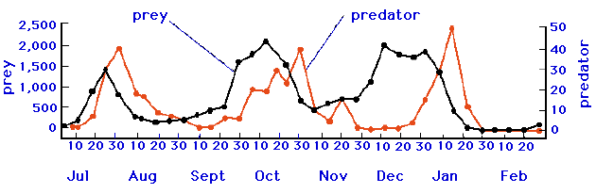

b) Predation is an example of a (circle one): Density Dependent Factor Density Independent Factor
c) Suppose a huge flood sweeps through the area where the reindeer live. This is an example of a (circle one):
Density Dependent Factor Density Independent Factor

6. Symbiosis describes an interaction between two different species. Identify each of the following interactions as either MUTUALISM, COMMENSALISM, or PARASITISM.
a) Epiphytes, such as orchids, are plants that live on other plants. They are able to have better access to sunlight because of this elevated position. They do not take any nutrients away from the other plant. ______________________
b) Clownfish live among the tentacles of sea anemones. The clownfish chase away butterfly fish, who normally feed on sea anemones. __________________________
c) Imperial Shrimp can be found riding on the backs of sea cucumbers in the oceans near Papua New Guinea. This way, the shrimp are able to travel to many different areas to get food without using up much energy. ____________________

7. Define and give an example of each of the following:
Aposematic coloring ________________________________________________________________________________
Batesian Mimicry __________________________________________________________________________________
Cryptic coloration __________________________________________________________________________________

8. Suppose the lakes and marshes in Florida have a high net primary productivity. What does this mean? How does this differ from the gross primary productivity? ______________________________________________________________
__________________________________________________________________________________________________

9. Suppose you are a city planner trying to determine how many rats are in the sewers of New York. You capture and tag 500 rats. You then release these rats and come back one week later. You capture another 500 rats. Of these newly captured rats, 100 have the original tag on them.
a) What is your estimate on the rat population in the sewer? _______________
b) Suppose you estimate that half of these rats will have 20 surviving babies each over the next year. Approximately 500 rats will die over the next year. 100 rats will migrate through the sewers to the country. No rats will move in from the outside. Based on your population size you estimated in part (a), what is the new population in the sewers after one year? ________
c) If this trend continues, the population will have exponential growth. This cannot continue forever though. What is one factor that might limit the exponential growth of this population of rats? __________________________________________________________________________________________

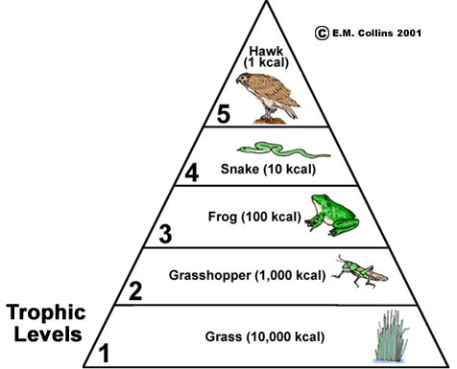
11. Use the following terms to label the food pyramid on the right: autotrophs, heterotrophs, secondary consumers.

12. The food pyramid on the right represents an average loss of 90% of energy at each trophic level. This is a general estimate. Upon further studies, you may find that certain transfers of energy from one trophic level to the next may vary. For example, how would a trophic level made up of mammals compare to a trophic level made up of fish in the efficiency of energy transfer to the next trophic level. (in other words, would mammals or fish "pass on" more energy to the next level?). Explain your answer.
_________________________________________________
__________________________________________________ img src: http://waynesword.palomar.edu/lmexer10.htm
__________________________________________________________________________________________

13. In an environment that is relatively unstable and unpredictable, would you expect organisms to rely more on r-selection or K-selection strategies for reproduction? Be sure to explain your answer. ___________________
__________________________________________________________________________________________
__________________________________________________________________________________________

14. You are working over the summer as an intern to a Marine biologist who has been monitoring a marine ecosystem off the coast of the Western United States. In this ecosystem, there are sea stars (Pisasters) as well as mussels and other invertebrates. Pisaster sea stars are the predators of the mussels as well as some of the other invertebrates. In one area of the ecosystem, the scientists have removed the sea stars while leaving them alone in another area. Over the course of several years, they have been tracking relationship between the number of Pisaster sea stars and the total species diversity in the area. Their data is shown in the graph below.
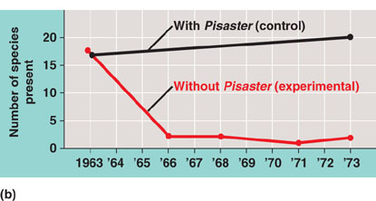

a) Based on the data, what role does the Pisaster sea star most likely play in the ecosystem? (choose one)
Producer Detritvore Keystone Species Dominant Species

b) Explain your answer to part (a).
c) In the are where the pisaster sea stars are removed, how would you expect the mussel population to change?
d) Name some of the abiotic and biotic factors that are present in this ecosystem.

