LIPID  (TRIGLYCERIDE)  mostly C-C and C-H bonds, making it very nonpolar | LIPID (STEROID)  3 6-carbon rings and 1 5-carbon ring, mostly C-C and C-H bonds | NUCLEIC ACID  Strands of nucleic acids bonded to one another by hydrogen bonds
Distinguish between  MONOMERS  and  POLYMERS | CARBOHYDRATE  Monosaccharide;  1:2:1 ratio of carbon:hydrogen:oxygen  RING FORM | PROTEIN  (AMINO ACID)  carboxyl, amino hydrogen and R group attached to a central carbon
PEPTIDE BOND | CARBOHYDRATE  Monosaccharide;  1:2:1 ratio of carbon:hydrogen:oxygen  STRAIGHT CHAIN FORM | NUCLEIC ACID  (NUCLEOTIDE)  phosphate, 5 C sugar and nitrogen base
PHOSPHOLIPID | Describe the  LEVELS OF  PROTEIN  STRUCTURE | Distinguish between STARCH,  CELLULOSE, and GLYCOGEN
ENZYME | CHITIN | Distinguish between UNSATURATED  and  SATURATED FATTY ACIDS

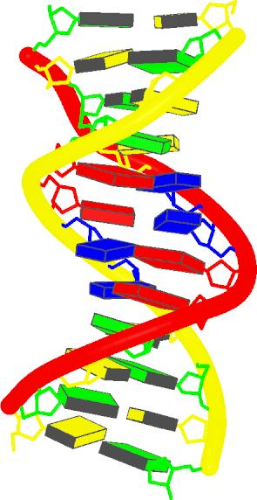 | 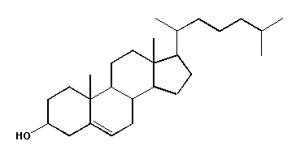 | 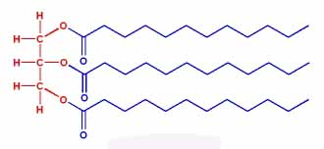
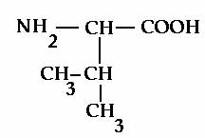 | 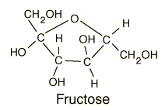 | Monomer- Single subunit that is used to build polymers.  Ex. Nucleotides, monosaccharides, amino acids  Polymer- A more complex structure made up of monomers bonded together by covalent bonds.  Ex. Nucleic acids, polysaccharides,  proteins
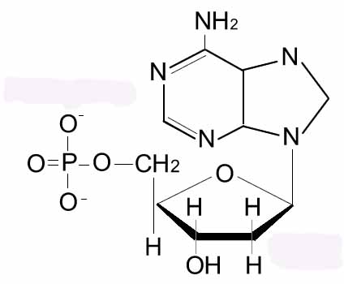 | 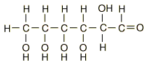 | Peptide Bond- The covalent bond that joins two amino acids together. These bonds help create primary structure in proteins.
Starch- A polysaccharide with a branched structure that is used as a storage form for carbohydrates in plants.  Cellulose- A polysaccharide with a linear chain structure that is used for structural support in plants.  Glycogen- A polysaccharide with a branched structure that is used as a storage form of carbohydrates in animals. | Primary Structure- The linear sequence of amino acids, joined together by peptide bonds.  Secondary Structure- Alpha helices and beta sheets resulting from hydrogen bonding  Tertiary Structure- 3D structure created by hydrogen bonds, disulfide bonds, ionic interactions, etc.  Quaternary Structure- Interactions between polypeptide chains. | Phospholipid- A specialized lipid that is composed of a phosphate group and two fatty acids attached to a glycerol molecule. This gives it a polar end (phosphate) and a nonpolar end (the fatty acids).
Saturated Fatty Acid- Contains only C-C single bonds. This linear structure allows fatty acids to get very close to one another and increases the van der Waal’s forces between them.  Unsaturated Fatty Acid- Contains at least one C-C double or triple bond. The bent shape (from these bonds) decreases the number of van der Waal’s forces between fatty acids. | Chitin- A polysaccharide found in the exoskeleton of insects and the cell walls of fungi. | Enzyme- A protein that catalyzes a specific chemical reaction. Enzymatic activity is affected by temperature and pH. Regulated through phosphorylation, cleavage, inhibition and feedback loops.

