Distinguish between

MONOMERS
and
POLYMERS

PEPTIDE BOND

PHOSPHOLIPID | Describe the  LEVELS OF  PROTEIN  STRUCTURE | Distinguish between STARCH,  CELLULOSE, and GLYCOGEN
ENZYME | CHITIN | Distinguish between UNSATURATED  and  SATURATED FATTY ACIDS

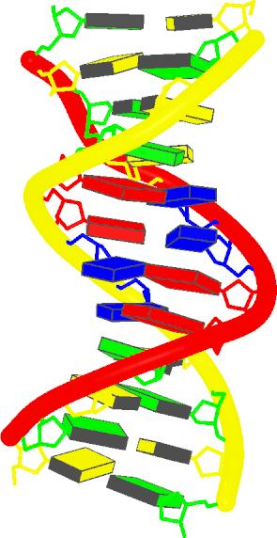 | 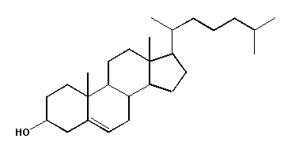 | 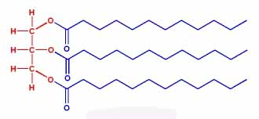
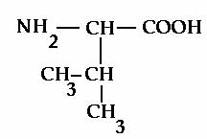 | 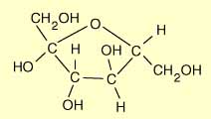 | Monomer- Single subunit that is used to build polymers.  Ex. Nucleotides, monosaccharides, amino acids  Polymer- A more complex structure made up of monomers bonded together by covalent bonds.  Ex. _______________, ____________,  _________________
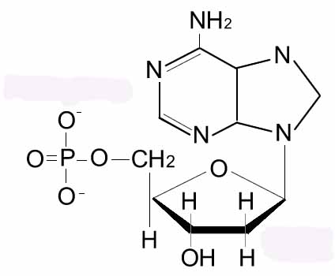 | 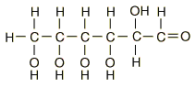 | Peptide Bond- The covalent bond that joins ________________ together. These bonds help create _____________ structure in proteins.
Starch- A polysaccharide with a ________ structure that is used as a storage form for carbohydrates in ___________.  Cellulose- A polysaccharide with a ______ chain structure that is used for structural support in _________.  Glycogen- A polysaccharide with a _____________ structure that is used as a storage form of carbohydrates in _______. | Primary Structure- The linear sequence of amino acids, joined together by __________________.  Secondary Structure- Alpha helices and beta sheets resulting from ____________ bonding  Tertiary Structure- 3D structure created by hydrogen bonds, disulfide bonds, ionic interactions, etc.  Quaternary Structure- Interactions between ____________________. | Phospholipid- A specialized lipid that is composed of a phosphate group and two fatty acids attached to a glycerol molecule. This gives it a ________ end (phosphate) and a _________ end (the fatty acids).
Saturated Fatty Acid- Contains only C-C ________ bonds. This linear structure allows fatty acids to get very close to one another and increases the __________________ between them.  Unsaturated Fatty Acid- Contains at least one C-C _____________ bond. The bent shape (from these bonds) decreases the number of _________________ between fatty acids | Chitin- A polysaccharide found in the ____________ of insects and the ____________ of fungi. | Enzyme- A protein that catalyzes a specific chemical reaction. Enzymatic activity is affected by ____________ and _______. Regulated through phosphorylation, cleavage, inhibition and feedback loops.

