BIOLOGY AP Name ___________________________
PRACTICE EXAM #1 PER 1 2 3 4 5 6 7

"I understand the Monta Vista Academic Code and will not give or receive any improper aid for this examination." signed ________________________________________

1. Water is one of the most abundant molecules in living organisms. It has several chemical properties that make it ideal for living organisms.
a) Explain, at a molecular level, how water is a polar molecule. Include the following terms in your explanation: electronegativity, hydrogen, oxygen, electrons. _________________________________
__________________________________________________________________________________
b) Describe the difference in structure between ice and water and give an example of how this may be beneficial to living organisms. _________________________________________________________
__________________________________________________________________________________

2. The ribosome is the site of protein synthesis in a cell. A protein is formed when two amino acids come together on the ribosome.
a) Classify this reaction as either a DEHYDRATION reaction or a HYDROLYSIS reaction. (circle one)
b) Draw the basic structure of an amino acid.

c) As a protein is made, it begins to fold into a specific structure. Discuss the four levels of protein structure and describe the interactions between amino acids at each level of structure.
__________________________________________________________________________________
__________________________________________________________________________________
__________________________________________________________________________________
__________________________________________________________________________________

3. Starch is found in all plants. The structure of this biomolecule is directly tied to its function.
a) What biomolecule category would you classify starch as? _____________________________
b) Describe how the structure of starch makes it an ideal molecule for its specific function. Be sure to state the structure, function, and the relationship. ___________________________________________
____________________________________________________________________________________

4. Two models of enzyme-substrate interactions have been proposed: the "induced fit" and "lock and key" methods.
a) Describe the difference between the "lock and key" and "induced-fit" models of enzyme-substrate interactions. _________________________________________________________________________
____________________________________________________________________________________
____________________________________________________________________________________
b) The active site of an enzyme is sometimes referred to as a cleft or crevice. The specific 3-dimensional shape of the active site is described by what degree of protein structure? _________________________
c) Name two ways that substrates are able to bind to the active site of an enzyme (at a molecular level).
1-____________________________________________________________________________
2-____________________________________________________________________________
5. The conversion of succinate to fumarate is catalyzed by the enzyme succinate dehydrogenase. Oxaloacetate is a molecule that has a very similar structure to that of succinate. There is evidence that oxaloacetate is an inhibitor of the enzyme succinate dehydrogenase.
a) Do you think oxaloacetate is a competitive or noncompetitive inhibitor? _______________________
b) Explain your answer to part (a). _______________________________________________________
____________________________________________________________________________________
c) Could the inhibition of succinate dehydrogenase be overcome by adding excessive amounts of succinate? YES or NO
d) Explain your answer to part (c). _______________________________________________________
___________________________________________________________________________________

6. The following diagram shows the heme synthesis pathway in eukaryotic cells. Numbers refer to specific enzymes that catalyze a specific reaction. The following questions refer to this diagram.
a) Suppose the active site of enzyme #3 is mutated so that its substrate can no longer bind to it. What substance might begin to build up to toxic levels within the cell? ______________________________
b) Suppose a transport protein is necessary to move coproporphyrinogen III from the cytoplasm into the mitochondria. If a cell did not produce this transport protein, what may happen? _________________
__________________________________________________________________________________
c) How many substrates can enzyme #4 recognize? ___
.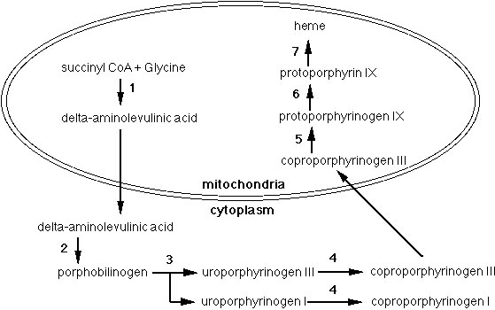

7. There are several different methods of enzyme regulation. The diagram below shows one such method.
a) What enzyme causes chymotrypsinogen to become active? ___________________________
b) Describe how the enzyme in question "a" does this. _______________________________________
___________________________________________________________________________________
c) What specifically links Chains A,B,and C of alpha-Chymotrypsin? ___________________________
d) How many amino acids does Chymotrypsinogen have? ________
e) How many amino acids does alpha-Chymotrypsin have? ________
f) Describe one other way that enzymes can be regulated (in general). __________________________
____________________________________________________________________________________
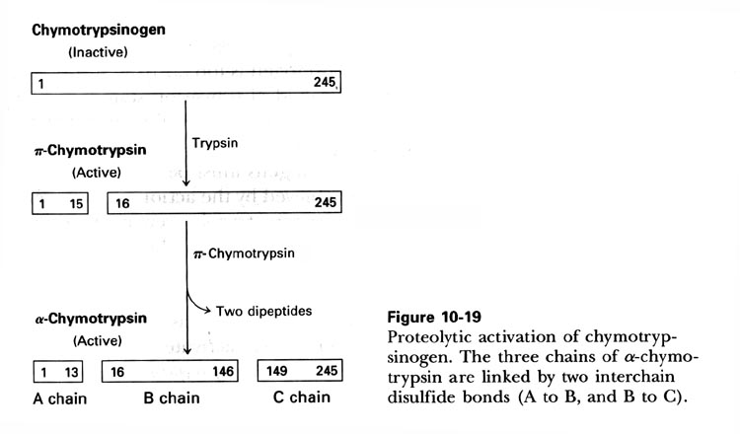
8. You are working for a professor in the Department of Biochemistry at UC Berkeley. You are investigating a newly discovered enzyme called MVBio-7. MVBio-7 is a protein that consists of 257 amino acids and is found in the cytoplasm of human cells. The substrate for this enzyme is citric acid. You begin your research by focusing on a small portion of the enzyme (amino acids #52 through #62 in the chain). The amino acid sequence of this region is: 52 VLIPMFVLFAV 62
Amino Acid Classification
Polar | Hydrophobic | Charged (Basic) | Charged (Acidic)
Glycine (G)  Serine(S)  Threonine (T)  Tyrosine (Y)  Cysteine (C)  Glutamine (Q)  Asparagine (N) | Alanine (A)  Valine (V)  Leucine (L)  Isoleucine (I)  Proline (P)  Tryptophan (W)  Phenylalanine (F)  Methionine (M) | Lysine (K)  Arginine (R)  Histidine (H) | Aspartic Acid (D)  Glutamic Acid (E)
a) The cytoplasm of cells is composed highly of water. Would you most likely find the 52-62 region in the inner portion of the protein or the outer portion of the protein? INNER or OUTER
b) Explain your answer to (a). __________________________________________________________
___________________________________________________________________________________
After careful experiments, you determine that the R groups of amino acids at positions 5, 7, 9, and 13 are very important in forming the active site of the MVBio-7 enzyme. They are vital in binding to the substrate (citric acid). Interestingly, glucose seems to inhibit the MVBio-7 enzyme. Glucose also seems to bind to the R groups of amino acids at position 5, 7, 9, and 13.
c) Describe two specific ways that a substrate may bind to the active site.
_____________________________________________________________________________
d) Would you describe glucose as a competitive or non-competitive inhibitor? ____________________
e) Explain your answer to (d). ___________________________________________________________
____________________________________________________________________________________
9. Recently, scientists have isolated a bacterial enzyme called phosphotriesterase that has the capability to break down toxins such as nerve gases (like sarin) and insecticides.
a) What kind of biomolecule is phosphotriesterase? (circle one)

PORPHYRIN LIPID CARBOHYDRATE PROTEIN NUCLEIC ACID

b) Suppose that when the nerve gas sarin is broken down into smaller, nontoxic molecules, the ΔG of the reaction is measured to be – 3.56 kcal. Draw the diagram
of this reaction on the graph to the right.
- Label the appropriate axes “Energy” and “Reaction Progress”.
- Label the products and reactants.
- Label the Activation Energy.

c) On the same graph, draw the reaction when phosphotriesterase catalyzes
the breakdown of sarin. Label this “With enzyme”.

d) Is the reaction that phosphotriesterase catalyzes (circle one)
ENDERGONIC or EXERGONIC

e) When phosphotriesterase is placed in a high pH or high temperature environment, it is no longer able to break down its substrates. Which of the following bonds may be broken to cause this result? (Circle all that apply)
peptide bond hydrogen bond ionic bond disulfide bonds

f) Given this potential for a bioterrorism antidote, the Department of Defense is interested in modifying phosphotriesterase so that it is able to catalyze the reaction even faster. To do this, they change a single amino acid that is part of the active site from a nonpolar amino acid to a positively charged amino acid. Use what you know about protein structure to explain how changing this amino acid could potentially improve (change) the enzyme’s ability to perform its function. __________________________________________________________________________________________
__________________________________________________________________________________________________
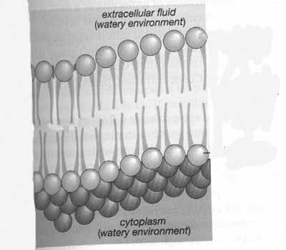
10. Scientists have isolated a type of bacteria that live at extremely cold temperatures such as those in the Arctic Circle. You are studying these organisms to determine what kinds of adaptations these organisms possess that make them well-suited to their environment.
a) Phospholipids, composed of phosphate groups and fatty acids, make up most of the cell membrane in all living organisms. A section of the cell membrane is shown on the right. Circle the part of the phospholipid bilayer diagram that contains the phosphate groups. Label it “phosphate”.

b) Which would you expect there to be more of in the phosholipids of these cold-loving bacteria? (circle one)
SATURATED FATTY ACIDS UNSATURATED FATTY ACIDS
c) Explain your answer to part (b) ____________________________________
________________________________________________________________
d) In order for molecules to enter or exit a cell, they have to get past the cell membrane. Because of its properties, the cell membrane is selectively permeable (only lets certain molecules through). Which of the two molecules (that are the same size) would be able to cross the cell membrane to get to the other side? (circle one)
NONPOLAR MOLECULE POLAR MOLECULE
e) Explain your answer to part (d) ____________________________________________________________________
________________________________________________________________________________________________

11. Any eukaryote cell has many different organelles and processes that contribute to the overall functioning of the cell. Match each of the cell terms with the appropriate definition. Each definition is only used once.
_____ Lysosome a. Free floating organelle that makes protein
_____ Golgi Apparatus b. Energy powerhouse of a plant cell.
_____ Smooth Endoplasmic Reticulum c. Where proteins are modified and sorted.
_____ Nucleolus d. Membranous sacs and tubes where proteins are synthesized.
_____ Rough Endoplasmic Reticulum e. Organelle where hydrogen peroxide is produced.
_____ Nucleus f. Energy powerhouse of an animal cell.
_____ Ribosome g. Region within nucleus where ribosomes are produced.
_____ Mitochondria h. Threads that allow for the movement of vesicles.
_____ Chloroplast i. Organelle with pores, so synthesized RNA can exit to the ER
_____ Microtubules j. Location where the cell membrane is synthesized.
_____ Peroxisome k. Organelle where macromolecules are broken down.

12. One characteristic shared by all cells is the presence of the plasma membrane. The plasma membrane is often described using the Fluid Mosaic Model.
a) Which of the following would you expect to cause the membrane to be more solid (less fluid). Check all that apply:
______ Presence of cholesterol at low temps ______ High Temperatures
______ Presence of saturated fatty acids ______ Low Temperatures
______ Presence of unsaturated fatty acids

b) Explain why the membrane is described as a mosaic. Be specific in your answer. _____________________________
__________________________________________________________________________________________________
__________________________________________________________________________________________

13. Lapland is an area in Finland characterized by many different types of plants. In many undeveloped regions of Lapland, there are also a diverse number of animals.

a) One region of Lapland, the Tornio River Valley has a net primary productivity that is 250 tons. The gross primary productivity is 300 tons. Based on this information, are the energy needs of the primary producers in this area (circle one):

HIGH or LOW

b) Explain your answer to part (a). _____________________________________________________________________

__________________________________________________________________________________________________

c) A new highway is built through a marshland in Lapland. Due to this, 2 kinds of frogs that occupy very similar niches and would normally interbreed, become isolated. Over time, they form distinct species. This is an example of: (circle one)
allopatric speciation sympatric speciation competitive exclusion trophic efficiency

d) As a scientist, you are studying the specific traits of these two frog species. You are focusing on the leg length of the frogs. Leg length has been shown in previous studies to correlate to the niche a frog occupies in an ecosystem. Because of the construction of the highway, how would you expect the leg lengths of the 2 frog species to compare to one another? Explain your answer.
__________________________________________________________________________________________________
__________________________________________________________________________________________________
e) Part of the land in Lapland is often cold and icy during the year. The melting permafrost amongst the low-growing plants makes the area into a wet marsh come summer. What biome is this? (circle one)
Tundra Taiga (Coniferous Forest) Savannah Chapparal Desert
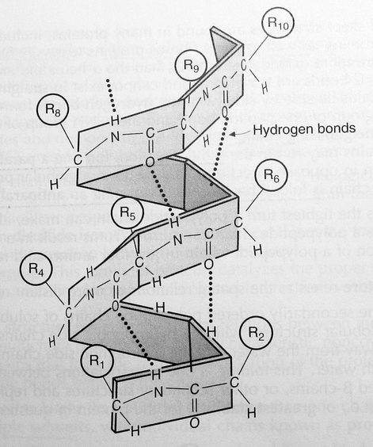
Use Diagram II to answer questions 12-13
Bond A A
14. What level of protein structure is shown in Diagram II?
a) secondary structure c) tertiary structure
b) quarternary structure d) none of the above

15. Bond A is an example of a
a) nonpolar covalent bond c) ionic bond
b) polar covalent bond d) hydrogen bond

16. The growth that occurs after a forest fire is considered:
a. Primary Succession b. Secondary Succession
Diagram II

17. Elephants have very few young and travel in family groups. An elephant's reproductive style could be considered:
a. r-selection b. K-selection

18. The two polynucleotide chains in a DNA molecule are attracted to each other by:
a. Covalent bonds between carbon atoms c. Hydrogen bonds between bases
b. Peptide bonds between amino acids d. Covalent bonds between phosphates and sugars

19. Phospholipids are classified as
a. nonpolar molecules c. polar molecules
b. both nonpolar and polar molecules d. neither nonpolar nor polar

20. Which class of biomolecules do steroids belong to?
a. nucleic acids c. carbohydrates
b. lipids d. proteins
21. When two cysteine amino acids form a di-sulfide bridge, what type of bond is formed?
a. nonpolar covalent bond c. hydrogen bond
b. ionic bond d. polar covalent bond

22. An enzyme increases the rate of a reaction
a. by supplying the energy needed to speed up a reaction c. by decreasing entropy
b. by lowering the activation energy of a reaction d. by lowering the deltaG of a reaction

23. All of the following are polymers of monosaccharides except
a. glycogen c. starch
b. cellulose d. glycerol

24. An enzyme that is brought to a lower temperature than its ideal temperature may:
a. Have more collisions with substrates
b. Begin to break hydrogen bonds between amino acids.
c. Become inflexible and may not allow the substrate to react in the active site.
d. Break covalent bonds between amino acids because it will freeze.
e. Lose its primary structure.

25. Which of the following is true of a pH 4.0 solution compared to a pH 6.0 solution.
a. The pH 4.0 solution has twice the number of H+ ions as the pH 6.0 solution.
b. The pH 4.0 solution is more basic than the pH 6.0 solution.
c. The pH 4.0 solution has ten times the number of OH- ions as the pH 6.0 solution.
d. The pH 4.0 solution has one hundred times the number of H+ ions as the pH 6.0 solution.

Lab Practical
26. Dr. E.N. Zyme is performing an experiment to test a new kind of cellulase using Cellazyme tablets. Cellazyme tablets act as a substrate for cellulase and release a blue dye upon digestion. Dr. Zyme incubates the cellulase and Cellazyme tablet at 40 degrees for 10 minutes at pH 9.0. After 10 minutes, he adds stop solution and then starts another reaction with cellulase and Cellazyme tablets at 50 degrees at pH 9.0. After this reaction has gone for 5 minutes, he adds stop solution to this reaction. After waiting five minutes, he filters the solutions with Whatman paper and uses a spectrophotometer to measure the amount of blue dye at 590 nm. The OD reading for the 40 degree sample is 0.432. The OD reading for the 50 degree sample is 0.314. He tells his boss that the new cellulase works best at 40 degrees. The boss laughs at Dr. Zyme and says that the data can't be used.
a) What experimental mistake did Dr. Zyme make? _________________________________________
___________________________________________________________________________________
b) Explain how Cellazyme tablets can be used to measure cellulase activity. _____________________
___________________________________________________________________________________
c) When using the spectrophotometer, should Dr. Zyme set the blank to 0% absorbance or 100% absorbance? Explain your answer. _______________________________________________________
___________________________________________________________________________________

27. Using a spectrophotometer, Dr. E.N. Zyme tests a series of samples that have been run by Biology AP students to determine the enzymatic activity of amylase at different temperature and pH conditions using Amylazyme tablets as the substrate (work the same way as Cellazyme tablets do). The readings from the spectrophotometer are shown in the table below.
experimental condition | OD (absorbance)
pH 7, 5 degrees Celsius | 0.002
pH 6, 50 degrees Celsius | 0.156
pH 4, 90 degrees Celsius | 0.089
According to this data, under which of the conditions was the amylase most active? Explain your answer by refering to the data and your knowledge of the spectrophotometer. ___________________________________
_________________________________________________________________________________________

You should also be able to indicate how to set a P1000 for a particular volume.

