BIOLOGY AP, KEY
PRACTICE EXAM #1

1a) Water is made up of two hydrogen atoms and one oxygen atom. Oxygen is more electronegative than hydrogen, so the electrons that are shared between the two in the covalent bond, are pulled more strongly toward the oxygen atom. This causes a partial negative charge on the oxygen atom and partial positive charges on the hydrogen atoms. The overall bend of the water molecule gives it an overall polarity (with a partially positive and partially negative side). (read chapter 3)
b) Ice is less dense than water because the water molecules align themselves in a crystalline matrix. This causes ice to float in lakes during the winters. This allows fish to survive in the insulated waters below.

2a) Condensation because it is a building reaction
2b) 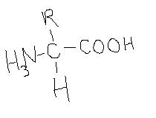
2c) There are four degrees of protein structure. These include: Primary (sequence of amino acids that are covalently bonded to each other), Secondary (alpha helices and beta-pleated sheets formed by hydrogen bonding), Tertiary (interactions between R groups, including ionic, nonpolar, hydrogen bonding, disulfide bonding), and Quaternary (interactions between separate polypeptide chains).

3a) Carbohydrate
3b) Starch's structure is a branched polymer of glucose monomers. Its function is to provide an ideal energy storage for plants. This structure allows for this function by allowing many glucose monomers to be accessible at one time.

4a) The "lock and key" model describes a situation where the substrate that fits exactly into an active site of an enzyme. There is no change in shape of either substrate or enzyme. The "induced-fit" model describes a situation where the substrate and active site "mold" to fit to each other. Biologists have determined that the "induced-fit" model is what really happens. See Figure 8.16 on page 153 of your textbook.
4b) Tertiary
4c) Substrates may bond to the active site by ionic bonds, hydrogen bonds, or hydrophobic interactions.

5a) Competitive
5b) This is an example of competitive inhibition because the structure of oxaloacetate is similar to succinate so they probably compete for the active site.
5c) Yes
5d) By adding excessive succinate, you could reverse the inhibition because you would be outcompeting the inhibitor for the active site.

6a) Porphobilinogen
6b) Coproporphyrinogen III might build up to toxic levels
6c) 2

7a) Trypsin
7b) Cleaves a peptide bond to make two chains of a protein
7c) Disulfide bonds
7d) 245
7e) 241
7f) Phosphates groups can activate/inactivate enzymes. Inhibitors can bind to the active site (or another site on the enzyme). Coenzymes such as vitamins or cofactors such as Ca2+ (and other ions) can bind to enzymes to activate or inactive them.

8a) Inner portion of the protein
8b) These amino acids are hydrophobic which will be repelled from the watery environment of the cytoplasm. This region will most likely be found in the inner folds of the protein.
After careful experiments, you determine that the R groups of amino acids at positions 5, 7, 9, and 13 are very important in forming the active site of the MVBio-7 enzyme. They are vital in binding to the substrate (citric acid). Interestingly, glucose seems to inhibit the MVBio-7 enzyme. Glucose also seems to bind to the R groups of amino acids at position 5, 7, 9, and 13.
8c) Hydrogen bonding, ionic bonding, van der waals forces, hydrophobic interactions.
8d) Competitive
8e) The glucose binds to the same region as the substrate.

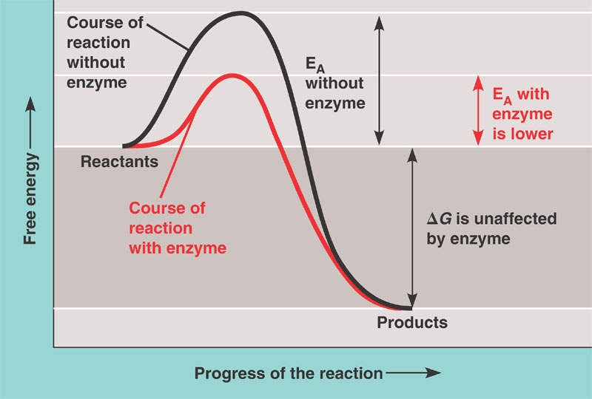
9a) protein
9b and c) It should look something like this:

9d) Exergonic
9e) hydrogen bond, ionic bond, disulfide bonds ( all tertiary structure bonds)
9f) Changing it to a positively charged amino acid will allow for additional ionic bonds between R groups. This could change the shape of the active site to allow it to bind to the substrate better than it did before.
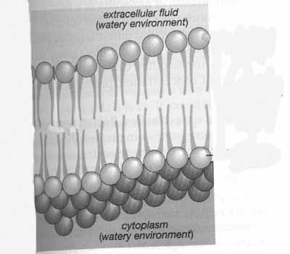
10a) phosphate area is circled

10b) unsaturated fatty acids
10c) If there were too many saturated fatty acids the membrane would be too solid at a cold temperature, thus killing the bacteria (like freezing it). At lower temperatures it is important for the membrane to remain fluid. This means you would want there to be more unsaturated fatty acids since they are able to remain more liquid/fluid at lower temperatures.

10d) nonpolar
10e) In order to get through the nonpolar center the molecule would also have to be nonpolar (and small). Note: water can pass through the membrane but it’s polar—it’s an exception.
11.
__K__ Lysosome
__C__ Golgi Apparatus
__J__ Smooth Endoplasmic Reticulum
__G__ Nucleolus
__D__ Rough Endoplasmic Reticulum
__I__ Nucleus
__A__ Ribosome
__F__ Mitochondria
__B__ Chloroplast
__H__ Microtubules
__E__ Peroxisome

12. One characteristic shared by all cells is the presence of the plasma membrane. The plasma membrane is often described using the Fluid Mosaic Model.
a) Which of the following would you expect to cause the membrane to be more solid (less fluid). Check all that apply:
______ Presence of cholesterol (at low temps) ______ High Temperatures
___X__ Presence of saturated fatty acids __X___ Low Temperatures
______ Presence of unsaturated fatty acids

12b) The membrane is a Mosaic because there are many different things in it such as phospholipids, proteins and carbohydrates.

13a) LOW
13b) Only 50 tons of energy used (only about 1/6 of the total energy produced)
13c) allopatric speciation
13d) They would probably be more similar because they are separated—they could occupy the same niche.
13e) Tundra

14) a
15) d
16) b
17) b
18) c – you don’t need to know this for this exam
19) b
20) b
21) a
22) b
23) d
24) c
25) d

26) a) He didn't allow the two reactions to run for the same amount of time.
b) As the amylase breaks down its substrate, a blue dye is released. If the amylase works more effectively, more blue dye is released. Thus, the amount of blue dye is proportional to the activity of the enzyme.
c) 0 absorbance. The blank should act as a "clear" sample, thus allowing all light to pass through it. You want to see how much is absorbed by later samples.

27) pH 6 at 50 degrees is the most ideal condition for this amylase. A higher OD absorbance means that the sample was darker. A darker sample means that more dye was released by the substrate, indicating a higher enzyme activity.

