BIOLOGY AP, September 19, 2003 KEY
PRACTICE QUIZ #2
Chemistry

1. Dissolve 46.07 g of C₂H₅OH into 1 L of water.

2. a) A hydrogen bond is when a hydrogen that is bound to an electronegative element (such as nitrogen or oxygen) is attracted to a third negatively charged atom.
b) A Van der Waals force is an momentary attraction between two atoms when they are extremely close to each other. This is caused when an atom has a slight charge on one side of it (because of the random distribution of electrons) and it is attracted to another atom with this same situation.
c) An ionic bond is the attraction between a full postively charged atom and a full negatively charged atom.
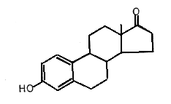
3. a) 18 carbons
b) 22 hydrogens
c) See diagram to right
d) No amino functional groups
e) 3
f) none

6. (d) is the answer.

7. HYDROLYSIS

9. See page 48-52 of your textbook for examples.

