BIOLOGY AP Name ___________________________
PRACTICE QUIZ #2 PER 1 2 3 4 5 6 7
Chemistry
"I understand the Monta Vista Academic Code and will not give or receive any improper aid for this examination." signed ________________________________________

1. If you wanted to make 1 L of a 1 M solution of C₂H₅OH, then you would...
Dissolve ___________ grams of C₂H₅OH into _________ liter(s) of water.

2. Describe each of the following forces between atoms:
a) Hydrogen bond _________________________________________________________________________
b) Van der waals force ______________________________________________________________________
c) Ionic bond ______________________________________________________________________________
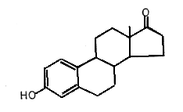
3. The diagram to the right is of an organic molecule.
a) How many carbons does it contain? _____
b) How many hydrogens does it contain? _____
c) Circle any alcohol functional groups.
d) Put a box around any amino functional groups.
e) How many double bonds between two carbons can be found? ____
f) How many triple bonds between two carbons can be found? ____

4. Which of the following is true of a pH 3.0 solution compared to a pH 6.0 solution.
a) The pH 3.0 solution has three times the number of H+ ions as the pH 6.0 solution.
b) The pH 3.0 solution is more basic than the pH 6.0 solution.
c) The pH 3.0 solution has 30 times the number of H+ ions as the pH 6.0 solution.
d) The pH 3.0 solution has one thousand times the number of H+ ions as the pH 6.0 solution.

5. Describe the following reaction as either a CONDENSATION or HYDROLYSIS reaction:
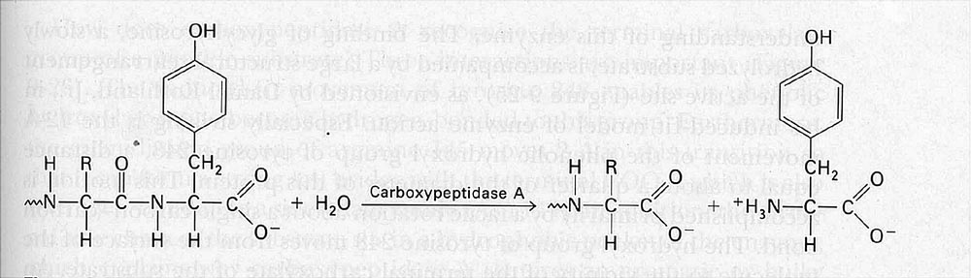

6. Describe two properties of water and give an example for each of their biological importance.
a) _________________________________________________________________________________
b) _________________________________________________________________________________

