BIOLOGY AP Name ___________________________
PRACTICE QUIZ #3A PER 1 2 3 4 5 6 7
Biomolecules
"I understand the Monta Vista Academic Code and will not give or receive any improper aid for this examination." signed ________________________________________
1. There are four classes of biomolecules:
lipids proteins/amino acids
nucleic acids/nucleotides carbohydrates
Classify diagrams B through P as one of these four biomolecule categories (write them next to the letter).
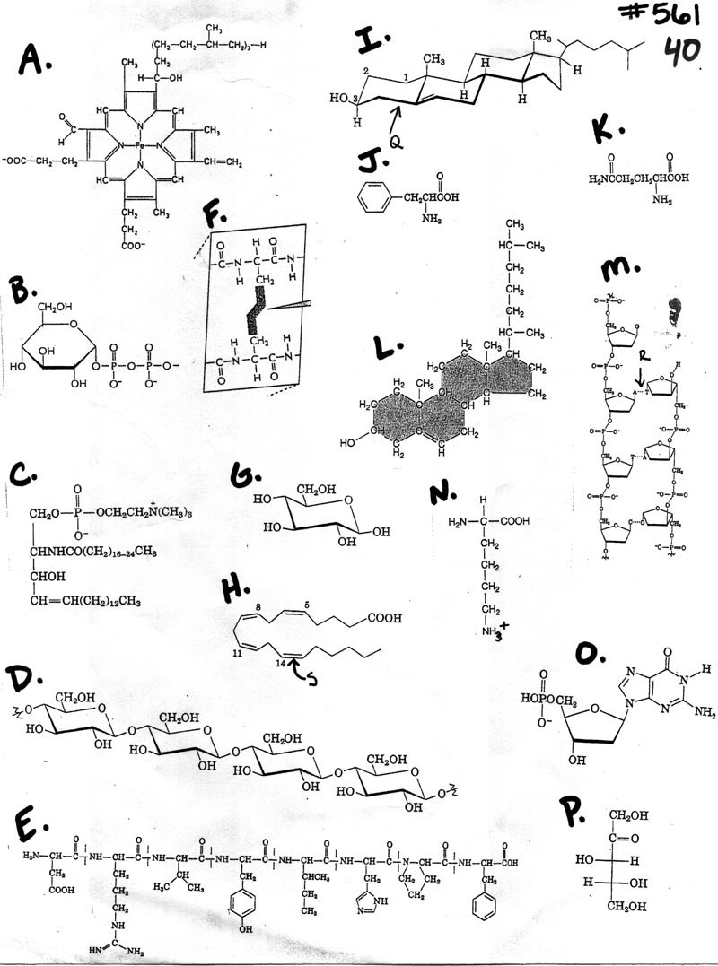
2. There are many different types of bonds that occur between atoms:
nonpolar covalent polar covalent ionic
hydrogen single bond double bond
triple bond
Identify ALL applicable bond characteristics of bonds Q, R, S (in the diagram on the previous page).
Q= ___________________________________________________
R=____________________________________________________
S=____________________________________________________
3. How many carbon atoms are found in biomolecule I? ____

4. Which amino acid has an R group that is capable of forming ionic bonds within a protein? ____

5. Which amino acid has an R group that is capable of participating in hydrophobic interactions within a protein? ____

6. Of the lipids, which is the MOST likely to be a liquid at room temperature? _____

Match the following biomolecules to their correct description. Each description is only used once.
7. Cholesterol ___ A. Lipid made up of three fatty acid chains and a glycerol
8. Starch ___ B. Monosaccharide
9. Glucose ____ C. Steroid found in cell membranes
10. Cellulose ____ D. Basic monomer of proteins
11. Triglyceride ____ E. Protein with a porphyrin group in it
12. Glycogen ____ K. Polysaccharide used for glucose storage in plants.
13. Lactose ____ G. Polysaccharide found in the cell walls of plants.
14. Hemoglobin ____ H. Polysaccharide used for glucose storage in animals.
15. RNA ____ I. Dissacharide
16. Amino Acid ____ J. Nucleic Acid

17. Circle one alcohol functional group in the diagrams (label it "alcohol").
18. Circle one amino functional group in the diagrams (label it "amino").
19. Circle one carboxyl functional group in the diagrams (label it "carboxyl").

APPENDIX:

Electronegativities of Common Elements
Hydrogen | 2.1
Oxygen | 3.5
Carbon | 2.5
Nitrogen | 3.0
Sulfur | 2.5
Phosphorus | 2.1
Sodium | 0.9
Chlorine | 3.0

Bond Type By Electronegativity
Electronegativity Difference | Bond Type
<0.3 | Nonpolar covalent
Between 0.3 and 1.7 | Polar covalent
>1.7 | Ionic

