BIOLOGY AP Name ___________________________
PRACTICE QUIZ #3B PER 1 2 3 4 5 6 7
Biomolecules
"I understand the Monta Vista Academic Code and will not give or receive any improper aid for this examination." signed ________________________________________
1. There are four classes of biomolecules:
lipids proteins/amino acids
nucleic acids/nucleotides carbohydrates
Classify diagrams A through O as one of these four biomolecule categories (write them next to the letter).
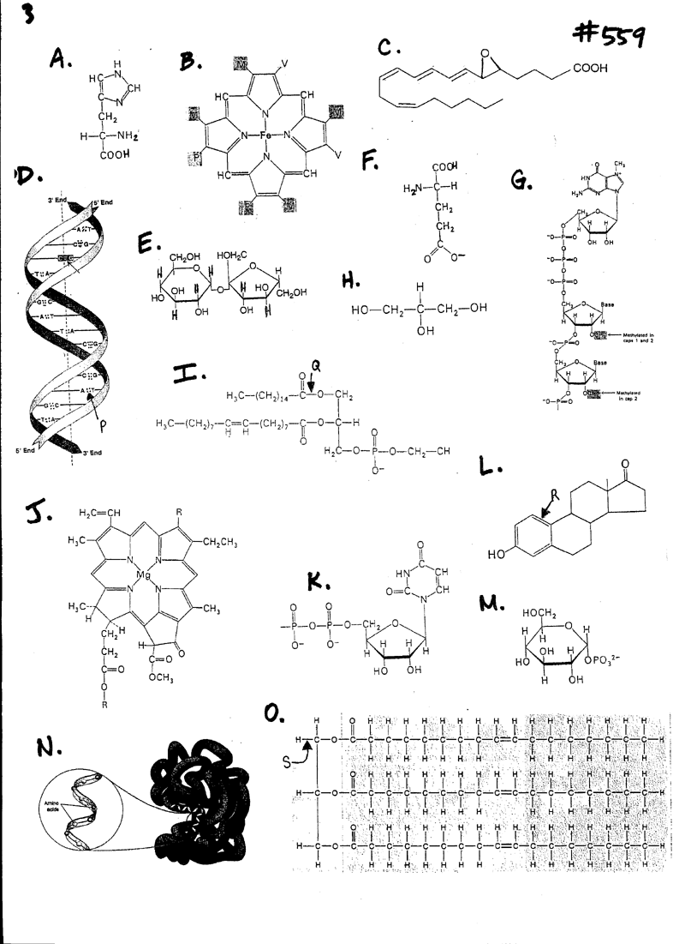
2. There are many different types of bonds that occur between atoms:
nonpolar covalent polar covalent ionic
hydrogen single bond double bond
triple bond
Identify ALL applicable bond characteristics of bonds Q, R, S (in the diagram on the previous page).
Q= ___________________________________________________
R=____________________________________________________
S=____________________________________________________
3. How many carbon atoms are found in biomolecule L? ____

4. Of the lipids, which is the MOST likely to be a liquid at room temperature? _____

Match the following biomolecules to their correct description. Each description is only used once.
5. Steroids ___ A. Lipid found in cell membranes
6. Starch ___ B. Disaccharide constructed from two glucose monomers
7. Maltose ____ C. Nonpolar molecules made up of carbon rings
8. Uracil ____ D. Basic monomer of proteins
9. Phospholipid ____ E. Nitrogenous base found ONLY in RNA
10. Chitin ____ F. Nitrogenous base found in RNA and DNA
11. Galactose ____ G. Polysaccharide used for glucose storage in plants.
12. Adenine ____ H. Polysaccharide found in the exoskeletons of insects.
13. DNA ____ I. Monosaccharide
14. Amino Acid ____ J. Nucleic Acid

15. Circle one alcohol functional group in the diagrams (label it "alcohol").
16. Circle one amino functional group in the diagrams (label it "amino").

17. What kind of interactions would you expect to find between
- polar amino acids
- nonpolar amino acids
- charged amino acids

18. What are the properties of water and how does the bonds water contribute to these properties?
You should also be able to do calculate the molar mass of a compound and determine how to make a solution of a specific molarity (refer to your problem set for examples)

APPENDIX:

Electronegativities of Common Elements
Hydrogen | 2.1
Oxygen | 3.5
Carbon | 2.5
Nitrogen | 3.0
Sulfur | 2.5
Phosphorus | 2.1
Sodium | 0.9
Chlorine | 3.0

Bond Type By Electronegativity
Electronegativity Difference | Bond Type
<0.3 | Nonpolar covalent
Between 0.4 and 1.7 | Polar covalent
>1.7 | Ionic

