Ch 25 Review WS AP Chemistry
Essential Questions: You should be able to answer the following essential learning questions at the end of Chapter 25.
- What is are hydrocarbons?
- How are alkanes, alkenes and alkynes different?
- How are hydrocarbons named?
- What are the different functional groups and how are they named?
- What is isomerism?
- How do structural, geometric and optical isomers differ from each other?
- Your own question (s)….
Connections to the real-world and other Chemistry Units
- What are some different organic compounds that we use in our day-to-day lives?
- Take a guess at number of organic compounds that an average teenager uses every day.
- How does knowledge of organic chemistry help you read and understand the labels of various foods and cosmetics?
- Could you live your life in an organic chemistry free world? Why or why not?
Level 1 Problems: Ch 25 PS #5, 7, 9, 10, 11, 15, 20, 23, 41, 44; Recommended: #2, 16, 17, 43, 69

Level 2 Problems: Organic Nomenclature

Given the structure, write both the name and the structural formula.

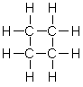
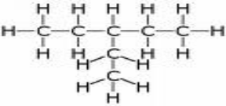

______________________ ______________________

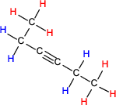
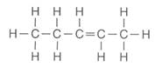

______________________ ______________________

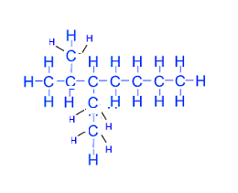

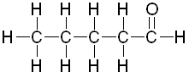

______________________ ______________________

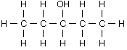
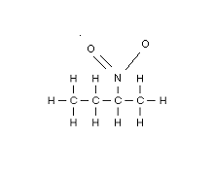

______________________ ______________________

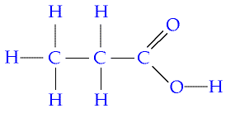
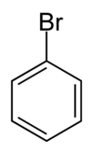

_______________________ ______________________
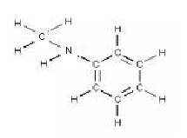

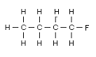

______________________ ______________________

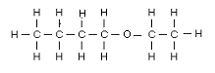

______________________

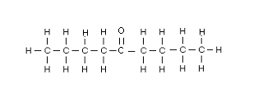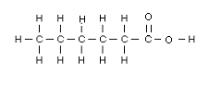

Draw condensed structural formulas for the follow hydrocarbons.

- 2,3-dimethylpentane

- 2,4-dimethylhexane

- cyclohexane

- 2,2-dimethylpropane

- 2,4-dimethyl-1-hexene

- 2,4,6-trinitromethylbenzene

- cis-2,3-dichloro-2-butene

- 1,1,2-trichloroethane

- 1,2-methylcyclohexane

- 1,4-dichlorobenzene

Organic Nomenclature
Given the structure, write both the name and the structural formula.

______cyclobutane_____ ____3-methylpentane___
C₄H₈ CH₃CH₂CH(CH₃)CH₂CH₃

_____trans-2-pentene____ _______3-hexyne_______
CH₃CHCHCH₂CH₂CH₃ CH₃CH₂CCCH₂CH₃

___3-ethyl-2-methylheptane___ _______1-_Pentanal______
CH₃CH(CH₃)CH(C₂H₅)CH₂CH₂CH₂CH₃ CH₃CH₂CH₂CH₂CHO

______3-pentanol_______ _____2-Nitrobutane______
CH₃CH₂CH(OH)CH₂CH₃ CH₃CH(NO₂)CH₂CH₃

___1-_Propanoic acid_____ _______Bromobenzene______
CH₃CH₂COOH C₆H₅Br

___1-Fluorobutane______ ____Methylphenylamine___
CH₃CH₂CH₂CH₂ CH₃NHC₆H₅

____butylethylether_____
CH₃CH₂OCH₂CH₂CH₂CH₃

1 -_Hexanoic acid______
5- Nonanone
CH₃CH₂CH₂C(O)CH₂CH₂CH₂CH₃ CH₃CH₂CH₂CH₂CH₂COOH

Draw condensed structural formulas for the follow hydrocarbons.

  - 2,3-dimethylpentane

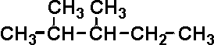

  - 2,4-dimethylhexane

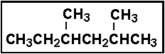

  - cyclohexene

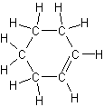

  - 2,2-dimethylpropane
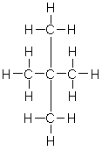

  - 2,4-dimethyl-1-hexene

  - 2,4,6-trinitromethylbenzene

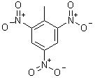

  - cis-2,3-dichloro-2-butene

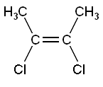

  - 1,1,2-trichloroethane
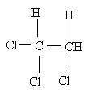
  - 1,2-dimethylcyclohexane

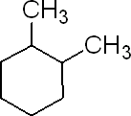

  - 1,4-dichlorobenzene

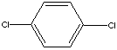

Isomers WS

1.How many structural isomers of heptane exist?

A) 2
B) 4
C) 6
D) 8
E) 9
Answer: E

2. How many structural isomers of heptane exist?

A) 2
B) 4
C) 6
D) 8
E) 9
Answer: E

3. How many structural isomers (include all types except optical) can be drawn for 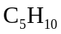?

A) 5
B) 6
C) 7
D) 11
E) 12

Answer: D

4. Which one of the following molecules is chiral?

A)
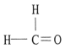
B)
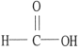
C)
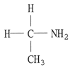
D)
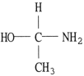
E)
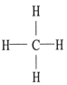

Answer: D

5. What types of isomerism are possible among the molecules that can be obtained by substituting a chlorine atom and a bromine atom for two of the hydrogen atoms in each of the following?
(a) Ethane, C₂H₆
(b) Ethene, C₂H₄
Show structures to illustrate each of the types of isomerism you name for each of these compounds.
Answer:
(a) positional (structural) isomers
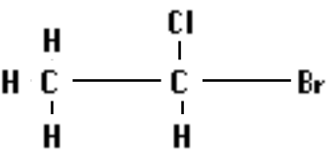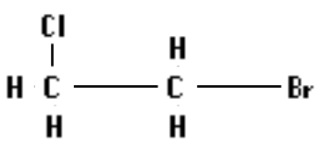
optical isomer:
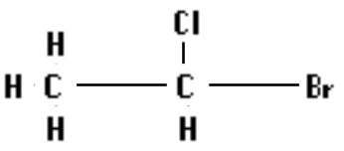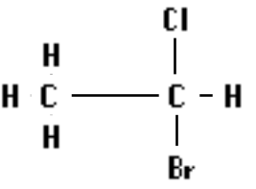
(b) positional (structural) isormers
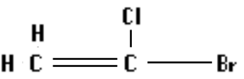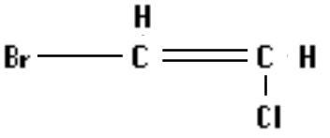
cis - trans isomers


